EXEMPT MASTER LOG BOOK

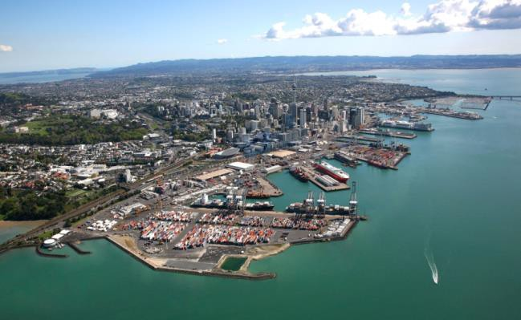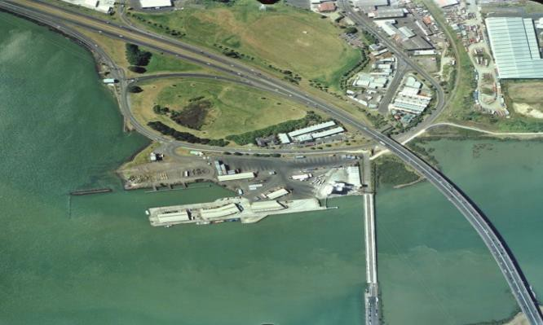

NAME:

IMPORTANT

Please forward a copy of pilotage acts and tug usage from this log book to the Harbourmaster by 31st March annually to verify currency and fulfil the requirement under Clause 59 of the Auckland Council Navigation Bylaw 2021.

No | Date | Movt A/D/R | Vessel Name | LOA | GRT | Berth | Bow  N/S/E/W | Tide (E/F) | Draft | Wind | Day/ Night | Thruster  (Y/N) | Tugs | Pilot / Exempt Master | Remarks
1
2
3
4
5
6
7
8
9
10
11
12
13
14
15
16
17
18
19
20
21
22
23
24
25

No | Date | Movt A/D/R | Vessel Name | LOA | GRT | Berth | Bow  N/S/E/W | Tide (E/F) | Draft | Wind | Day/ Night | Thruster  (Y/N) | Tugs | Pilot / Exempt Master | Remarks
1
2
3
4
5
6
7
8
9
10
11
12
13
14
15
16
17
18
19
20
21
22
23
24
25

No | Date | Movt A/D/R | Vessel Name | LOA | GRT | Berth | Bow  N/S/E/W | Tide (E/F) | Draft | Wind | Day/ Night | Thruster  (Y/N) | Tugs | Pilot / Exempt Master | Remarks
1
2
3
4
5
6
7
8
9
10
11
12
13
14
15
16
17
18
19
20
21
22
23
24
25

No | Date | Movt A/D/R | Vessel Name | LOA | GRT | Berth | Bow  N/S/E/W | Tide (E/F) | Draft | Wind | Day/ Night | Thruster  (Y/N) | Tugs | Pilot / Exempt Master | Remarks
1
2
3
4
5
6
7
8
9
10
11
12
13
14
15
16
17
18
19
20
21
22
23
24
25

