Proposed changes to some central crosstown bus services
Consultation—feedback open until midnight 13 December 2019
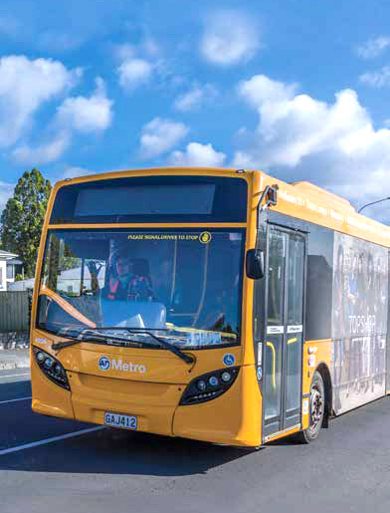
AT Metro. Have Your Say …
AT.govt.nz/haveyoursay

Adapted in accordance with Section 69 of the Copyright Act 1994 by the Royal New Zealand Foundation of the Blind, for the sole use of persons who have a print disability.
Produced 2019 by Accessible Formats Service,
Blind & Low Vision NZ (formerly Blind Foundation), Auckland, for Auckland Transport.
Total print pages: 4
Total large print pages: 10

Notes for the Large Print Reader
Main text is in Arial typeface, 18 point.
Headings are indicated as:

Heading 1

Heading 2

Heading 3

Heading 4

Omissions and alterations
Print page numbers are omitted.
The maps have been omitted, and replaced with route descriptions.

Page 1

Proposed changes to some central crosstown bus services
Auckland Transport is proposing some changes to crosstown bus services that affect the OuterLink and 650 routes. We'd like to hear your views on these changes.
- Read about the project details: AT.govt.nz/about-us/news-events/proposed-changes-to-the-outerlink/
- Find out about giving feedback on the Newmarket access improvements: AT.govt.nz/projects-roadworks/newmarket-access-improvements/

Consultation—feedback open until midnight 13 December 2019
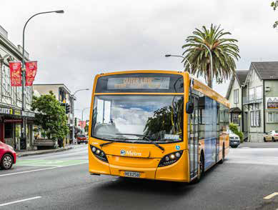

Improving crosstown bus services
We've heard from you that the OuterLink isn't working as well as it should; it's not reliable and buses are catching up to each other along the route meaning you sometimes wait a long time for a bus and then two turn up at once. It's not meeting its frequent promise of a bus every 12 to 15 minutes.
Circular routes such as the OuterLink are problematic as they are required to wait at various locations along the route in order to adhere to the timetable; this often happens while passengers are on board which offers a poor journey experience.
And we know that people can't make some crosstown journeys as easily as they would like because there is a gap in the frequent bus network along Balmoral Rd and Green Lane West and Green Lane East.
So we are proposing changes to some of the buses that cross Auckland's central isthmus area to address these problems.
By focussing on the most used section of the OuterLink we can improve the reliability of the service for the majority of current users. Boosting the frequency on route 650 will enable more crosstown journeys to be made as directly as possible along Balmoral Rd and Green Lane, allowing more people to get to more destinations, more often.
These proposals are designed to create an improved service for most people. They will complete the simpler, more frequent and better connected system of bus routes in the St Lukes, Mount Eden, Balmoral and Greenlane areas.
Find out more about Auckland's new bus network here: AT.govt.nz/newnetwork

New route 640
Route 640 will be introduced in May 2020 to assist with journeys when Mt Eden Station temporarily closes to enable construction on the City Rail Link. It will operate between Valley Rd and Newmarket via Mt Eden Station. See the map overleaf for details of the route. We propose to extend the 640 route to Kingsland via Walters Rd subject to the necessary infrastructure being in place.
Route description:
640—Valley Rd shops to Newmarket
Stop C Valley Rd Shops (1043), ahead Valley Rd,
left Mt Eden Rd, right Boston Rd, right Khyber Pass Rd, right Broadway, Stop C Newmarket (7204)
640—Newmarket to Valley Rd shops
Stop A Newmarket (7203), ahead Broadway,
left Khyber Pass Rd, left Boston Rd, left Mt Eden Rd,
right Valley Rd, Stop D Valley Rd Shops (1404)

What is being proposed:

Changes to the OuterLink route
- Removing the section of the OuterLink route between St Lukes and Newmarket via Balmoral/Mt Eden where there is duplication with other routes to provide better reliability of the remaining section of the route.
- Removing the need for buses to wait at Victoria Park.

Increasing the frequency of route 650
- Route 650 will be renamed as route 65 and its frequency will increase to every 15 minutes between 7am and 7pm, seven days a week, it will also operate later in the evening.
- There will be no change to the existing route path.

More services on Manukau Road
- Adding more bus trips to Manukau Rd at peak times.

New school bus service
A new school bus service will be introduced between Manukau Road schools and Balmoral and Mt Eden. It will travel on Mt Eden Rd, Valley Rd, Dominion Rd and Balmoral Rd on its way to and from Epsom schools.

How does this affect me?
- Most people will see no change to the way they travel.
- Some existing customers may need to transfer between buses and/or trains to complete the journeys they are currently doing.
No bus stops will lose bus services and all existing journeys can continue to be made. Even if the changes mean you need to transfer between two buses, or a bus and train, your journey may be quicker

Transfers
If these changes are made, some passengers might need to transfer between buses to complete their journey.
We are currently exploring options to make transferring between buses on Green Lane West and Manukau Rd more convenient.
Find out about transferring between buses and trains when paying with an AT HOP card at AT.govt.nz/athop
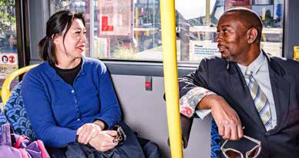

Maps

Current routes: Map 1
[TN]: Map 1 is omitted.

Proposed new routes: See Map 2
[TN]: Routes from Map 2 are described below.

The proposed new routes
OuterLink will operate in both directions between St Lukes, Mt Albert, Pt Chevalier, Westmere, Herne Bay, City Centre, Parnell and Newmarket.
Route 30 will have additional trips added at peak times
Route 65 will operate at least every 15 minutes from 7am to 7pm, seven days a week. It will also operate before and after these times at a lesser frequency.
Route 640 will be introduced May, 2020 before the proposed changes to the OuterLink and 650. It will operate in both directions between Valley Rd and Newmarket (Broadway) via Mt Eden Station and Grafton Station every 15 minutes at peak times and every 20 minutes at other times. At Newmarket it will start and finish near 277 Broadway.
There are no proposed changes to any other bus routes.

How do these proposed changes affect your current journey?

St Lukes to Mt Eden Village
Take the new frequent route 65 from St Lukes to Mt Eden Rd and transfer there to any 27 bus that travels along Mt Eden Rd

Mt Eden Village to Manukau Rd
- Take new route 640 to Newmarket and transfer there to the 30 or 309 for Manukau Rd
- Use new school bus if you are a student travelling to school

Epsom to Parnell
- Take the frequent route 30 or route 309 along Manukau Rd and transfer at 277 Broadway to an InnerLink or OuterLink travelling to Parnell

St Lukes to Newmarket
Take new frequent route 65 to Manukau Rd and transfer there to the frequent route 30 or route 309 to Newmarket and city
From Morningside Dr take a 22 bus to Morningside Station and transfer to the train to Newmarket.

Mt Eden Village to Dominion Rd
Take route 640 from Valley Rd near Mt Eden Village

Newmarket to College Hill
No change but with a more reliable OuterLink service

Newmarket to Wellesley St
No change but with a more reliable OuterLink service

St Lukes to City Centre
Take route 22 from Morningside Drive

Westmere or Herne Bay to Wellesley St and City Universities
No change but with a more reliable OuterLink service with better journey times

Give feedback on the proposed crosstown bus changes
Give us your views on the proposed new bus services before the end of the day on 13 December 2019. Go to the feedback form at AT.govt.nz/haveyoursay
Please be sure to tell us what you do like, and what you don't like about the proposals, so we can get balanced feedback. This will help us to understand how the proposed changes could benefit the widest group of customers. Thank you for taking the time to give us your feedback.

Come and talk to us
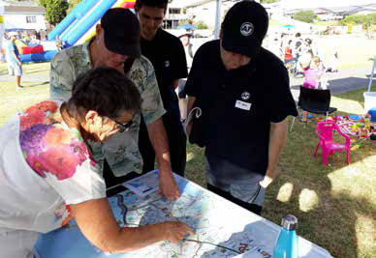
Come to one of our public information events and talk to our team about the proposed changes:
- 25 Nov, 10am-2pm Pt Chevalier Library,
1221 Great North Rd. Pt Chevalier
- 27 Nov, 11am-2pm bus stops opp 277 Broadway, Newmarket
- 28 Nov, 3pm-7pm Victoria Park Market bus stop,
210 Victoria St West, City Centre
- 3 Dec, 10am-2pm Mt Albert Library, 84 St Lukes Rd, St Lukes
- 5 Dec, 11am-2pm Mt Eden War Memorial Hall,
489 Dominion Rd, Mt Eden
- 7 Dec, 10am-1pm Mt Eden Village Centre,
449 Mt Eden Rd, Mt Eden

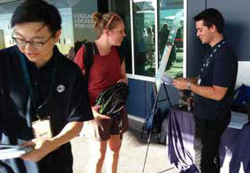

After feedback closes
We will:
1. Consider your feedback and use it to revise the proposal.
2. Prepare a report by early 2020 that outlines any changes to the proposal and our final decisions. If you provide your contact details, we will notify you when the report is available.
3. Promote changes, if any are made, on buses, at bus stops, in the Central Leader newspaper, on social media, on the AT Mobile app and journey planner and to registered AT HOP card holders who have opted in to received public transport updates.
If changes are made they would likely be implemented in the second half of 2020.
End of Proposed changes to some central crosstown bus services

