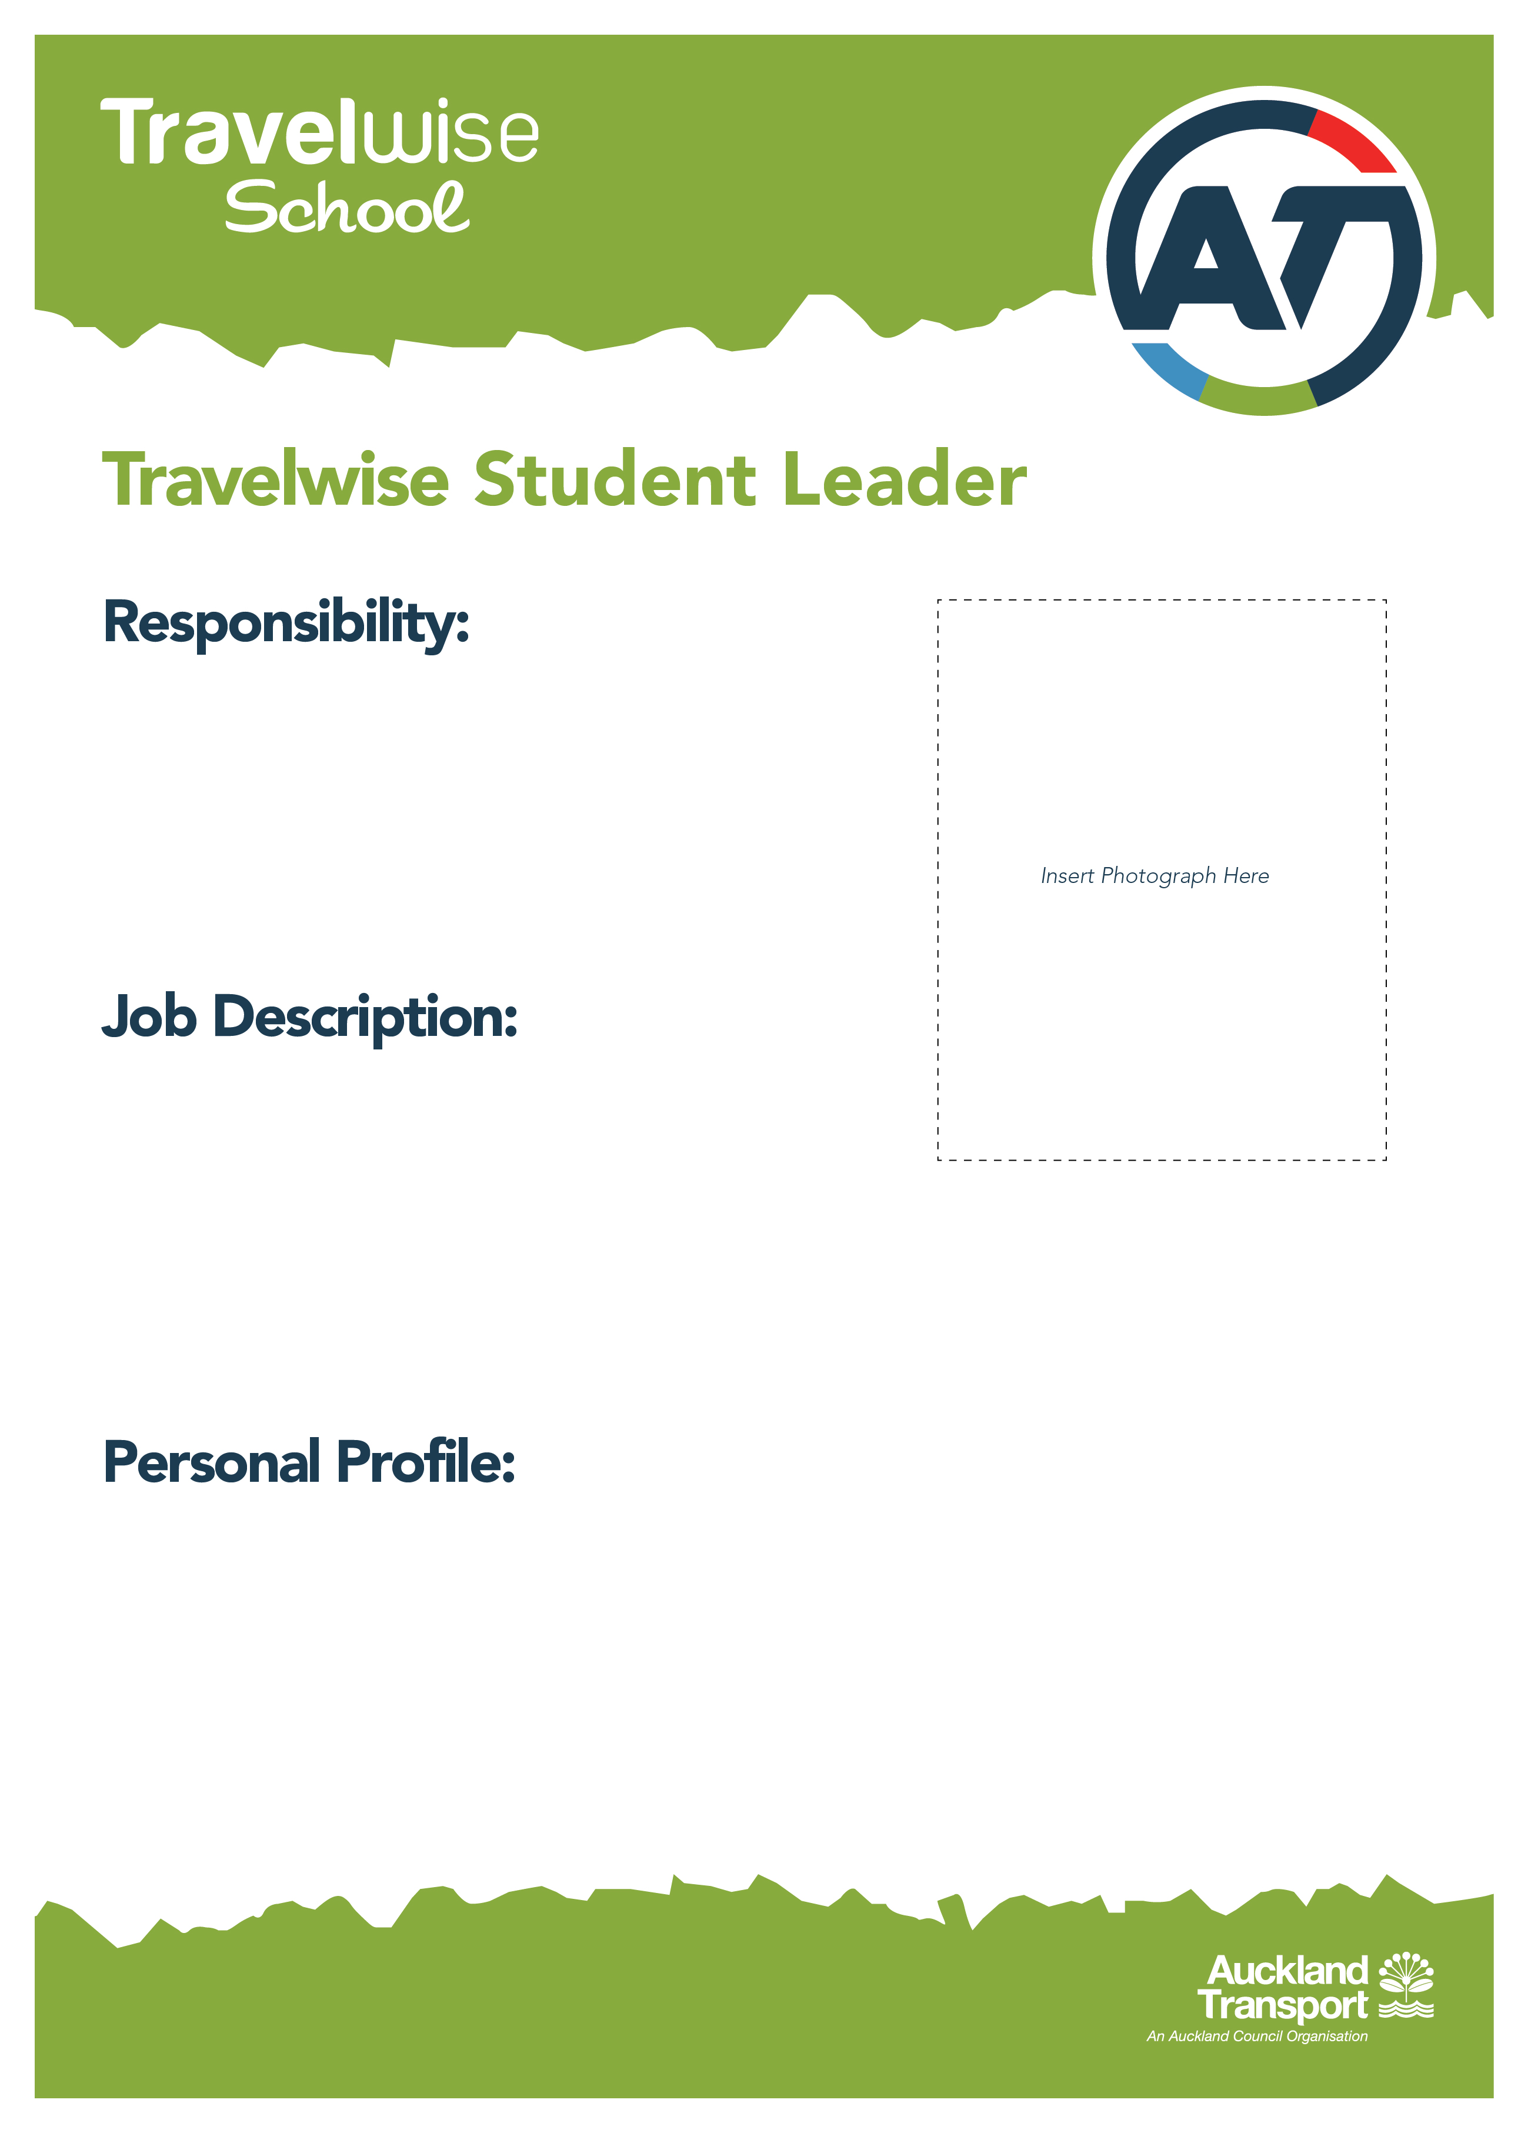

**Leader**

* (Why I am a Travelwise Leader)
* (Write 3 interesting facts about yourself)
* Coordinates Projects
* Sets meeting dates
* Acts as contact person with
* Lead Teacher (LT)
* Community Transport Coordinator (CTC)

Name:

Year level:

Room Number:

Date of Birth:



**Administrator**

* (Why I am a Travelwise Leader)
* (Write 3 interesting facts about yourself)
* Takes minutes of meetings
* Links to planning overview

Name:

Year level:

Room Number:

Date of Birth:

**Finance Team**

* (Why I am a Travelwise Leader)
* (Write 3 interesting facts about yourself)
* Looks after budget
* Applies for Travelwise grants

Name:

Year level:

Room Number:

Date of Birth:



**Presentation Team**

* (Why I am a Travelwise Leader)
* (Write 3 interesting facts about yourself)
* Presents at Assemblies
* Prepares Class Talks
* TV station front person

Name:

Year level:

Room Number:

Date of Birth:



**IT Team**

* (Why I am a Travelwise Leader)
* (Write 3 interesting facts about yourself)
* Writes Blogs
* TV
* Updates Website
* Produces PowerPoint Presentations

Name:

Year level:

Room Number:

Date of Birth:



**Creative Team**

* (Why I am a Travelwise Leader)
* (Write 3 interesting facts about yourself)
* Designs posters/ flyers and
* Produces them
* Designs/Creates Events

Name:

Year level:

Room Number:

Date of Birth:



**Marketing Team**

* (Why I am a Travelwise Leader)
* (Write 3 interesting facts about yourself)
* Runs Promotions
* Puts up posters/flyers around school
* Prepares Newsletter Items

Name:

Year level:

Room Number:

Date of Birth: